Chapter 1

**INTRODUCTION**

* 1. **What is LCC**

Nitrogen (N) fertilizer is important in rice production. Apply N fertilizer several times during the growing season to ensure that the crop's nitrogen need is supplied, particularly at critical growth stages. The Leaf Color Chart (LCC) is used to determine the N fertilizer needs of rice crops. LCC has four green strips, with color ranging from yellow green to dark green. It determines the greenness of the rice leaf, which indicates its N content [1]. Leaf Color Chart (LCC) is an instant, easy and low-cost technique for N diagnosis of current crop and N topdressing in crops. LCC an intelligent tool will help Rice. Maize & Wheat farmers to visually assess the need for nitrogen and apply the fertilizers. The color panels of the LCC are designed to indicate whether rice. maize. wheat plants are hungry or over-fed by nitrogen fertilizer. By matching the color of the rice. maize. wheat leaf to the color on the LCC. farmers can decide proper time and amount of N fertilizer for application. Leaf Color Chart ensure only need-based optimum use of chemicals in agriculture. Chemical fertilizer particularly urea is having indiscriminately applied to rice. maize and wheat in intrusively cultivated regions. There is an urgent need to rationalize the use of urea and other nitrogenous fertilizer (organic and inorganic) in a way that these are applied as per the need of the crop by using LCC. [2]

* 1. **Advantages of LCC**
* Better Crops
* Avoid Diseases
* Fertilizer at Right Quantity at Right Time when Crops needs
* Save Money for Farmers o Huge subsidy savings on N fertilizer for Govt.
* Reduces GHG Emission

The use of LCC in Punjab state in India. recommended by the Punjab Agricultural University for maize. rice and wheat crops. can result in saving of Rs 170 crore (38 Million USD) annually as well as the environment [2]

* 1. **Why LCC**

With the use of LCC in irrigated rice. let us assume a potential saving of 23 kg N or 50 kg urea per ha per season. The calculated annual savings of urea are provided in the table below for selected Asian countries (except China). The estimated annual saving of urea is 834.000 tons for India if 50% of farmers use LCC in the irrigated rice area of 22.3 million ha.

Other countries that could save substantial amounts of urea when they adopt LCC are Indonesia. Vietnam. Bangladesh and the Philippines. For the whole of Asia. except China. the potential annual saving of urea is estimated at 1. 2. 3 and 4 million tons. respectively. with 25. 50. 75 and 100% of farmers using LCC in irrigated rice. [2]

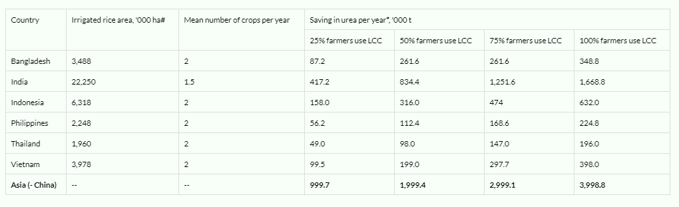

Figure 1.1: Saving urea using LCC

* 1. **Problem Statement**

LCC is a discrete system. Not a continuous system. Some time farmer can not detect the correct label for leaf for this farmer does not get the expected result. Ph diverse from the optimal Ph. Over fertilization causes high cost under fertilization cause low yield.

* 1. **Motivation**

Bangladesh is agriculture-based county. Though Digital Bangladesh was declared but our farmer uses fertilization manually. Some farmer does not use LCC at all. But most of the people has smart phone. They can use their smart phone camera for capture image for fertilization. For this reason, I have developed this system.

* 1. **Contribution Summary**

Our main objectives are to develop a system which will solve our problems and fulfill all our challenges. So, we need some features into our system which are given below:

* Paddy fertilizer monitoring system.
* Auto notify the farmer for fertilization
* Auto segmentation.
* Online and Offline mode. (Because some farmer does not have internet on their smart phone)